How to Purchase a SANS Subscription & Assign Access
Institutional subscriptions can only be purchased by a program coordinator. Residents may not purchase a subscription for themselves. The CNS offers SANS for Individual Learners for those who wish to purchase SANS products for individual use.

- Program Coordinator should log into their CNS account.

- Click on My CNS in the upper right corner next to your email. You should see “Switch to” at the bottom of the menu options. Click on your institution’s name which will switch to your
institutional admin account.
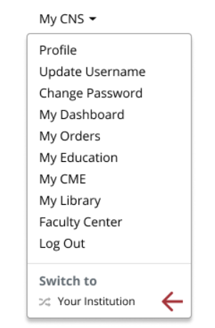

- Click on the Education header at the top of the page

- Click on SANS for Residency Program Coordinators

- Click on the button to Purchase Institution Subscriptions
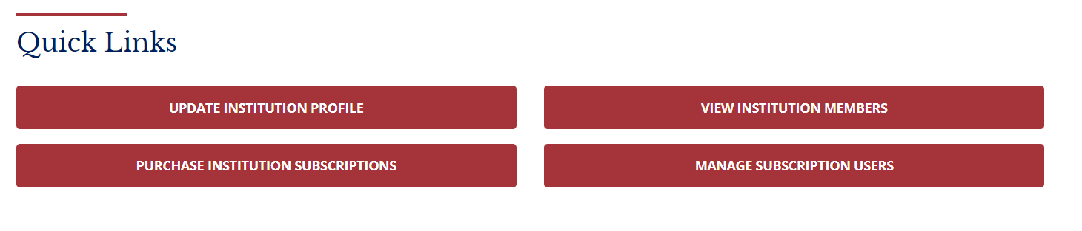
- You should now see all the available SANS modules with descriptions and pricing. Click on Buy Today to purchase the desired product.
- Enter the quantity needed then click Proceed. All SANS subscriptions are on a per user basis so each resident will need their own subscription. i.e., if you have 3 residents, you will need to purchase 3.
- Click No Thanks if you do not wish to make a donation.
- You will be brought to the payment screen where you can submit your credit card payment. (For payment by check, please contact education@cns.org for further information.)
To grant access to your residents:
- Once you have completed your payment, go back to the Education header, go to SANS for Residency Program Coordinators, and click on the red button for Manage Subscription Users.
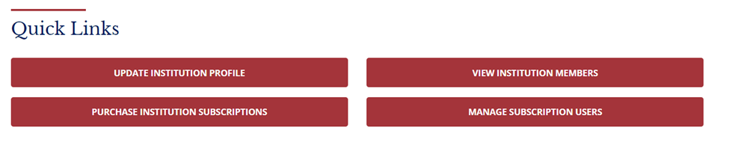
- Find the subscription you purchased. Click on the little pencil icon to assign seats (residents).
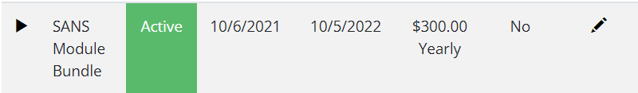
- Scroll down to Institution Seats and click on Edit. Then click Add Member.
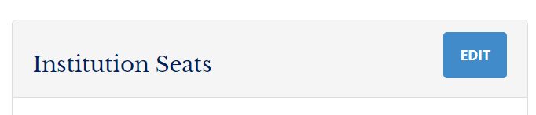
- Select resident’s name from the drop-down menu and Save.
  - If you do not see your resident’s name in the drop-down menu, you will need to add them to your institution first.
  - Go back to the Education header at the top of the page
  - Click on SANS for Residency Program Coordinators
  - Scroll down and click on the red button for “View Institution Members”
  - Click on the Edit button to add new residents.
  - To add a new resident, click on the Add Contact button. Type their name in the Contact field. The system will search for the account by name. Please allow a few seconds for the system to search as it can be slow.
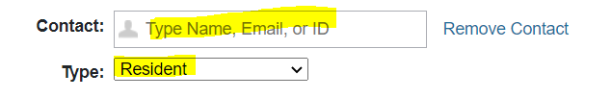
  - If the resident has more than one account, be sure to select the one that says Resident (CNS) next to their name. If you do not select the one that says Resident (CNS), the subscription will not link to the right account. Select “Resident” for the account type.
  - When finished adding residents to institution, go back to Manage Subscription Users to assign them to a SANS module.
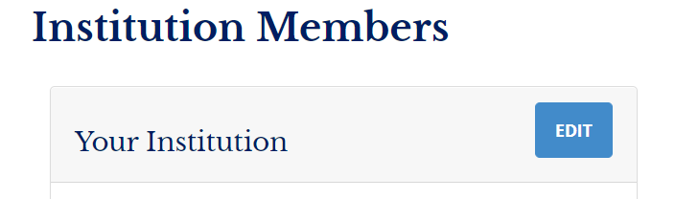
- Once you have finished assigning seats, your resident can log into their own CNS account, click on My CNS in the upper right corner next to their email address, then click on My Education to access the exam.
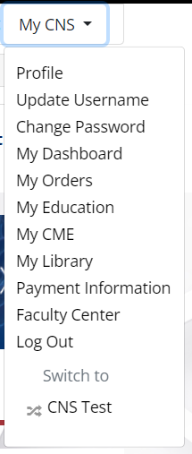
- You will need to notify your residents directly when access is ready as the system is not set up to send automatic notifications.
- Click on “Switch To” (under My CNS) to return to your regular CNS user account.

Please email any questions to education@cns.org.

